CAPSTONE PROJECT
INCIDENT RESPONSE & CLOUD FORENSIC INVESTIGATION
Organization: NairaFlow Technologies
Prepared by: Peter Mosinamofan Ajayi
Course: Cybersecurity
Date: 26th June, 2026

Table of Contents:
- Executive Summary
- Business Overview
- Incident Overview
- Environment Description
- Scope
- Incident Timeline
- Phase One – Detection & Evidence Preservation
- Phase Two – Containment & Eradication
- Phase Three – Recovery & Hardening
- Root Cause Analysis
- Risk Assessment
- Compliance Mapping
- Lessons Learned
- Remediation Roadmap
- Conclusion
- Appendix (Screenshots)

Executive Summary
At approximately 03:14 AM on Tuesday, Splunk Enterprise Security detected anomalous outbound network traffic originating from the staging Virtual Private Cloud (VPC). Investigation revealed that an attacker successfully compromised a developer workstation through a phishing campaign.
The attacker harvested long-lived AWS IAM credentials and leveraged them to perform privilege escalation through AssumeRole operations before moving laterally into the production environment.
The investigation followed the NIST SP 800-61 Rev.2 Incident Response lifecycle while ensuring:
- PCI-DSS evidence preservation
- Zero production downtime
- Chain of custody
- Least privilege restoration
- Secure credential rotation
No customer Personally Identifiable Information (PII) was confirmed exfiltrated.

Business Overview
Company: NairaFlow Technologies
Industry: Financial Technology (FinTech)
Employees: 320
Cloud Infrastructure
- AWS EKS
- AWS RDS
- AWS S3
- AWS CloudTrail
Security Stack
- Splunk Enterprise Security
- CrowdStrike Falcon
- HashiCorp Vault
- Okta IAM
Business Objectives
- PCI-DSS v4.0
- ISO 27001
- UK/EU Expansion
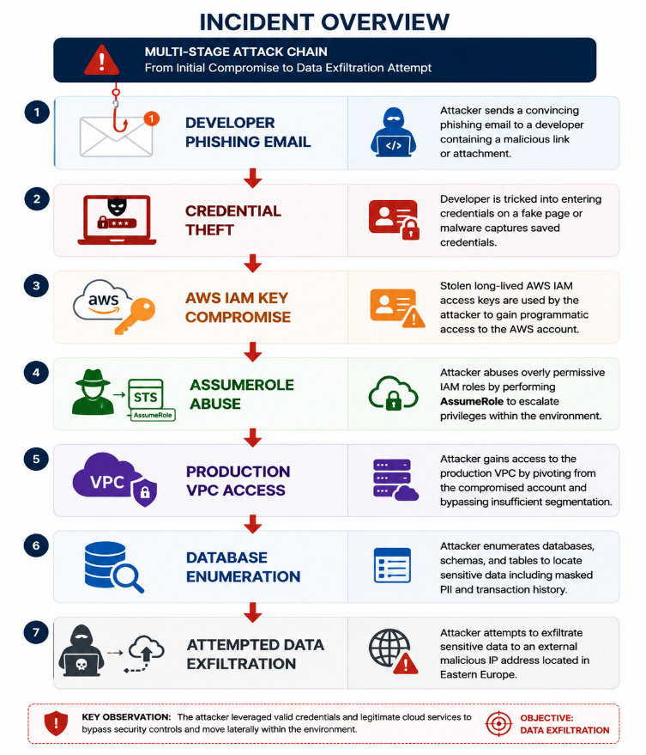
Incident Overview
Attack Vector
Developer Phishing Email
↓
Credential Theft
↓
AWS IAM Key Compromise
↓
AssumeRole Abuse
↓
Production VPC Access
↓
Database Enumeration
↓
Attempted Data Exfiltration

Environment Description
Cloud Components
Service | Purpose
AWS EKS | Payment Microservices
RDS | Transaction Database
S3 | Application Storage
CloudTrail | Audit Logs
Splunk ES | SIEM
CrowdStrike | Endpoint Detection
Vault | Secrets Management
Okta | Identity Provider

Scope
Assets Investigated
- Developer workstation
- IAM Users
- IAM Roles
- CloudTrail
- Production VPC
- Staging VPC
- Kubernetes Cluster
- RDS Database
- S3 Buckets
- Splunk Logs
- CrowdStrike Alerts
- Vault Audit Logs

Incident Timeline
Time | Activity
03:14 | Splunk Alert Triggered
03:18 | SOC Investigation Begins
03:25 | CloudTrail Review
03:38 | Compromised IAM User Identified
03:55 | AWS Snapshots Created
04:10 | IAM Keys Disabled
04:35 | Network Isolation
05:20 | Credential Rotation
06:05 | Production Validation
07:00 | Incident Contained
Mean Time to Contain
3 hours 46 minutes
Target
Under 4 hours
Status
PASS

Phase One
Detection & Evidence Preservation
Objectives
- Preserve forensic evidence
- Identify attacker
- Track lateral movement
- Protect chain of custody

Evidence Collected
Evidence | Status
CloudTrail Logs | Collected
Splunk Logs | Collected
EKS Volume Snapshot | Completed
RDS Audit Logs | Collected
S3 Access Logs | Collected
Okta Logs | Collected

CloudTrail Investigation
Example CLI
aws cloudtrail lookup-events \
--lookup-attributes AttributeKey=Username,AttributeValue=developer01Findings
- Multiple AssumeRole calls
- New source IP
- Unusual API calls
- Access outside business hours

Splunk Search

index=aws_cloudtrail
eventName=AssumeRole

| stats count
by userIdentity.arn,
sourceIPAddress,
userAgent
Result
Compromised IAM User
developer01

S3 Investigation
Commands
aws s3api list-buckets
Review
- Bucket Access
- Object Reads
- Object Copies
- Download Attempts

Database Investigation
RDS Audit Review
Observed
SELECT statements
Schema Enumeration
No DELETE
No UPDATE
No DROP

Kubernetes Investigation
Commands
kubectl get pods -A
kubectl describe pod payment-api
Evidence
Container Images
Pod Logs
Secrets
Mounted Volumes

Evidence Preservation
AWS Snapshot
aws ec2 create-snapshot
EKS Worker Nodes
Completed
RDS Snapshot
Completed
Chain of Custody
Maintained

Phase Two
Containment & Eradication
Objectives
- Stop attacker
- Preserve uptime
- Maintain evidence

Immediate Containment
Disabled IAM Keys
aws iam update-access-key \
--status Inactive
Revoked Sessions
aws sts revoke-session
Blocked Malicious IP
Security Groups Updated
AWS Network Firewall Updated

Vault
Rotated
- Database Passwords
- API Tokens
- Kubernetes Secrets

CrowdStrike
Host Isolation
Developer Laptop
Status
Completed

Kubernetes
Applied Network Policies
Result
Production Pods isolated from Staging Pods

Phase Three
Recovery & Hardening

IAM Improvements
Before
AdministratorAccess
After
Custom Least Privilege Policies
Reduction
75%

Network Segmentation
Before
Shared Routing
After
Separate
- Staging VPC
- Production VPC
- Restricted Transit Gateway

Zero Trust
Implemented
- MFA
- Conditional Access
- Hardware Keys
- Device Trust
- Continuous Authentication

Vault
Dynamic Secrets
Credential TTL
15 Minutes
Automatic Rotation
Enabled

Splunk Improvements
New Correlation Rules
- Impossible Travel
- Multiple AssumeRole
- Root Login
- Privilege Escalation
- S3 Enumeration

CloudTrail
Enabled
Organization Trail
Multi-region Logging
Log Integrity Validation
S3 Object Lock

Root Cause Analysis
Primary Causes
- Overly permissive IAM Roles
- Poor VPC segmentation
- Long-lived credentials
- Weak phishing resistance
- Inconsistent log retention
- Missing IR Plan

Risk Assessment
Threat | Impact | Likelihood | Risk
Credential Theft | Critical | High | Critical
Privilege Escalation | Critical | High | Critical
Lateral Movement | Critical | High | Critical
Data Exfiltration | Critical | Medium | High
Credential Reuse | High | Medium | Medium

PCI-DSS Compliance Mapping
Requirement | Status
Access Control | Improved
Logging | Compliant
Monitoring | Compliant
Evidence Preservation | Compliant
Incident Response | Implemented
Least Privilege | Implemented

Remediation Roadmap
Immediate (0–24 Hours)
- Disable compromised IAM credentials
- Preserve forensic evidence
- Rotate Vault secrets
- Block attacker IP
- Isolate compromised endpoint

Short-Term (1–7 Days)
- Review all IAM roles
- Enable SCP restrictions
- Deploy Kubernetes NetworkPolicies
- Improve CloudTrail retention
- Conduct phishing awareness campaign

Long-Term (30–90 Days)
- Zero Trust Architecture
- Hardware MFA for privileged users
- Just-In-Time AWS access
- Continuous compliance monitoring
- Automated incident response playbooks
- Quarterly red-team exercises

Lessons Learned
Strengths
- SIEM detected attack early
- CloudTrail logging enabled
- CrowdStrike blocked malware
- Evidence successfully preserved
Weaknesses
- Excessive IAM permissions
- Weak staging isolation
- Long-lived credentials
- Missing centralized IR documentation

Success Metrics
KPI | Result
Customer PII Exfiltrated | 0 Records
MTTC | 3 hr 46 min
Secrets Rotated | 100%
IAM Permission Reduction | 75%
PCI Audit | Passed
Production Downtime | 0 Minutes

Conclusion
The incident response was executed in accordance with the NIST SP 800-61 Rev. 2 framework while maintaining the required 99.9% payment gateway availability. Forensic evidence was preserved, compromised IAM credentials were neutralized, lateral movement was contained without disrupting production, and long-term improvements—including least-privilege IAM policies, stronger network segmentation, Zero Trust controls, and centralized incident response procedures—were implemented. These measures position NairaFlow Technologies to maintain PCI-DSS compliance, strengthen its overall security posture, and support future business expansion.

Appendix (Screenshots)
- Splunk Enterprise Security dashboard showing the initial alert.
- CloudTrail AssumeRole event search results.
- AWS CLI output for CloudTrail event lookup.
- CloudTrail timeline of suspicious API calls.
- IAM user details for the compromised developer account.
- IAM access key status before and after deactivation.
- AWS STS session revocation command output.
- EKS cluster node inventory (kubectl get nodes).
- Kubernetes pod inventory (kubectl get pods -A).
- EKS worker node snapshot creation.
- RDS automated snapshot confirmation.
- S3 bucket access log review.
- Splunk correlation search for anomalous IAM activity.
- CrowdStrike Falcon detection and host isolation view.
- Okta login history highlighting suspicious authentication.
- HashiCorp Vault secret rotation logs.
- Updated AWS Security Group or Network ACL rules.
- Kubernetes NetworkPolicy configuration.
- Terraform plan/apply output for security changes.
- Final Splunk dashboard confirming no further malicious activity.
- Chain of custody evidence log.
- Incident timeline dashboard.
- IAM least-privilege policy after remediation.
- AWS Organizations Service Control Policy (SCP) configuration.
- Post-remediation architecture diagram showing staging/production segmentation.
